Anti-Ragging committee
Chairman (Principal)

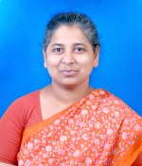
Mrs. K.Helen Rani

Coordinator Assistant Coordinator Faculties
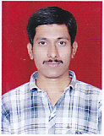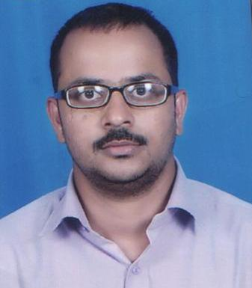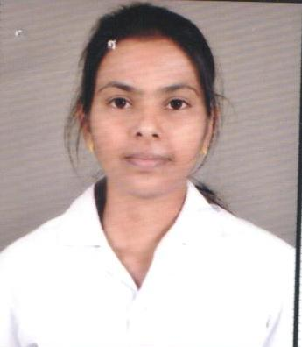
Mr. Madhusudana K.G Mrs. Sheetal M. Udaykar Mr. Sanket. S Ms. Deepali Ingle
Squads Students
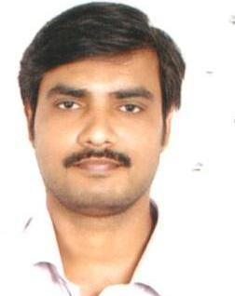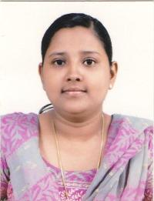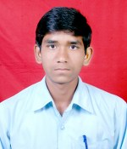
Mr. Siva Subramanian Mrs. Jessie Angel Dyana Mr. Mane Sandeep IV Year Ms. Wanjare Vishaka IV Year

